Report - Estimation of obesity level
Introduction
The aim of this report is to explore the obesity dataset and estimate obesity-related characteristics using statistical methods and probability distributions. The obesity dataset contains 2,111 observations and 17 variables that covering demographic characteristics, physical measurements, eating habits, lifestyle factors, and obesity levels. These variables divided into two main types: numerical and categorical.
The numerical variables include 8 features: Age, Height, Weight, FCVC, NCP, FAF, CH2O, and TUE. This analysis mainly focuses on Age, Height, and Weight, poisson distribution for NCP and FAF. These chosen variables provide information about physical characteristics which is relevant to exploring obesity levels.
The categorical variables include 9 features: Gender, family_history_with_overweight, FAVC, SMOKE, SCC, CAEC, CALC, MTRANS, and NObeyesdad. In whoIe analysis, I mainly focused on family history with overweight, Smoke and NObeyesdad.
- The libraries that I imported
- Pandas: used to load, and analyse the dataset
- NumPy: used for numerical calculations and mathematical operations
- Matplotlib: used to create graphs and histograms to visualise the data
- Seaborn: used to visualise data distributions and relationships between variables
- SciPy Stats: used for statistical analysis, probability distributions, and outlier detection.
- Statistical Overview
The describe() function in Python was used to summarise the eight numerical variables in the obesity dataset. It provides important descriptive statistics, including the mean, standard deviation /typical spread of observations around their average/, minimum, maximum, and the 25th, 50th/representing the median/, and 75th percentiles.
The head and tail shows automatically first 5 and last five data in my dataset. If head(10), it shows first 10th values of dataset.
The info() gives you general information of your dataset, such as colums’ names, null value, object/word value/, float/number value/.
Statistics | Result |  |  | Explanation
Statistics | Age | Weight | Height | Explanation
Mean | 24.31 | 86.59kg | 1.7016cm | The average value
Median/ P50 | 22.77 | 83.00kg | 1.7004cm | The middle value
Mode | 18.00 | 80.00kg | 1.700cm | Most frequently value in a dataset.
Distribution explantion | Mean>Median >Mode.  The tail extends to the right. | Mean>Median >Mode.  The tail extends to the right. | Symmetric →mean ≈ median ≈ mode. | *
Q1/ P25 | 19.94  25% of the participants are 19.95 years old or younger. | 65.47kg  25 % of the participants are 65.47 kg or less. | 1.63 cm  25 % of the participants are 1.63cm or shorter | Q1/P25 indicates 25% of data falls below this value
Q3 / P75 | 26.00  75% of the participants are 26 years old or younger. | 107.43 kg  75% of the participants are 107.43 kg or less. | 1.76 cm  75% of the participants are 1.76 cm or shorter. | Q3/P3  indicates 75% of data falls below this value
Min | 14.00 | 39.00kg | 1.450cm | These are the smallest values
Max | 61.00 | 173.00kg | 198.00cm | These are the largest values
Std | 6.34 | 26.19kg | 0.09cm | These values show how far the data points are from the mean.
Var | 40.27 | 685.97 | 0.0087 | Variance measures the degree of dispersion in a data collection.

Formulas:
- MEAN- sum of all data points/ number of data points
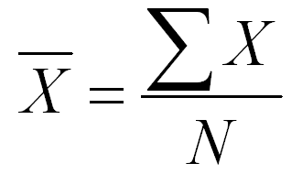
- MEDIAN
(n is odd): [(n + 1)/2]th term Data Median
(n is even): [(n / 2)th term + ((n / 2) + 1)th term]/2

- STANDART DEVIATION
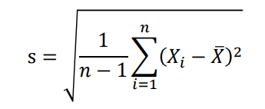
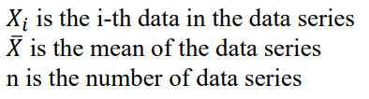
- Missing Values
The isnull() function shows that all variables have 0 missing values. This means the dataset is complete, and no missing data were found in any of the columns.
Python code- df.isnull().sum()
- Purpose of the Boxplot for Age, Weight, Height
Boxplots were used to visualize the distributions of age, height, and weight and to identify potential outliers. It shows the median-q2, quartiles/25, 75/, and spread of age, weight and height values, helping me understand how these values vary and whether any unusually high or low values exist.
A box plot uses boxes and lines to depict the distributions of one or more groups of numeric data. Box limits indicate the range of the central 50% of the data, with a central line marking the median value. Lines extend from each box to capture the range of the remaining data, with dots placed past the line edges to indicate outliers. https://www.atlassian.com/data/charts/box-plot-complete-guide.
- Age Boxplot - The median age is approximately 22 years, while the middle 50% of participants are aged between approximately 20 and 26 years. The lower whisker extends to around 13-14 years, and the upper whisker reaches approximately 35 years. Several outliers are visible above the upper whisker, particularly among participants aged over 35 years, with the highest value reaching approximately 61 years. No clear outliers are visible below the lower whisker. This indicates that most participants are relatively young, while a smaller number are considerably older.
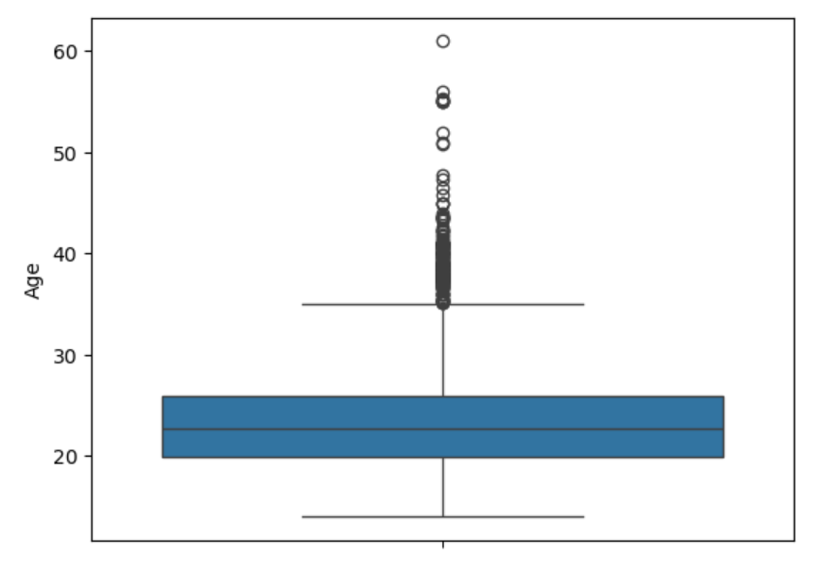
- Weight Boxplot - It shows that the median weight is approximately 83 kg. The middle 50% of participants' weights range from approximately 65 to 107 kg, indicating considerable variation in weight within the dataset. The lower bounder extends to approximately 39 kg, while the upper bounder reaches around 163 kg. One potential outlier is visible at approximately 170 kg, indicating an unusually high weight relative to the majority of observations. No clear lower outliers are visible. Overall, the boxplot indicates considerable variability in participants' weights, with some individuals having substantially higher weights than the central group.
The upper bounder is substantially longer than the lower whisker, and a high outlier is present, suggesting a possible right-skewed distribution. https://www.simplypsychology.org/boxplots.html
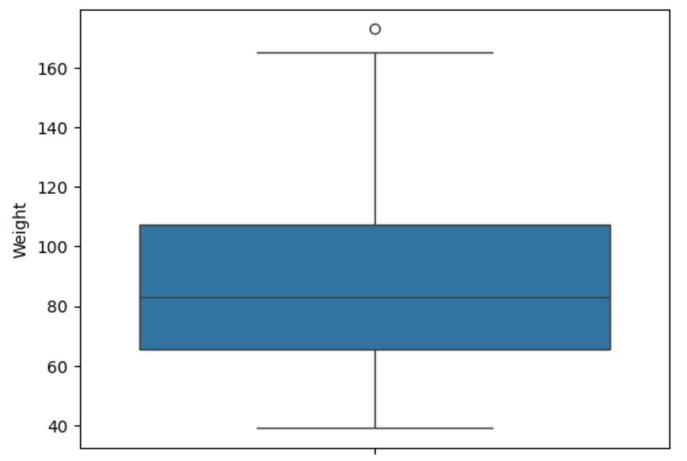
- Height Boxplot - The median height is approximately 1.70 metres. The middle 50% of height values range from around 1.63 to 1.77 cm, indicating the spread of heights among the central half of participants. The whiskers extend from approximately 1.45 to 1.98 cm. One potential outlier is visible near 1.98 cm, representing a participant whose height is unusually high compared with the rest of the dataset. No clear lower outliers are visible. Overall, the height values are relatively concentrated around the median.
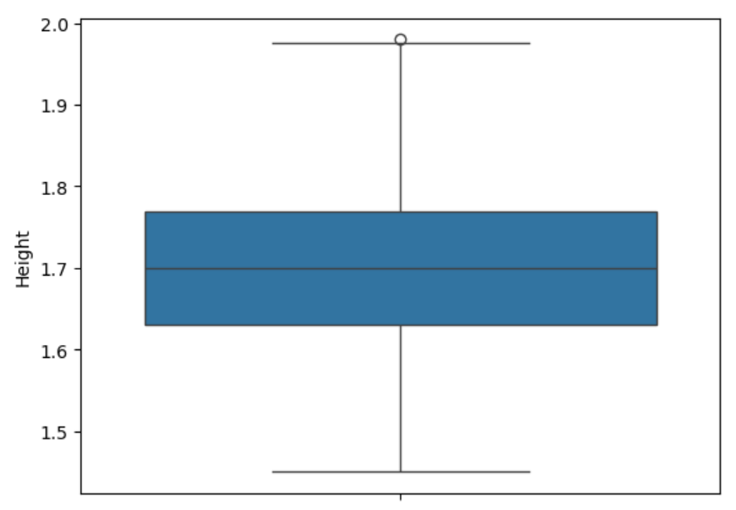
- Identifying the lower and upper bounds and exact number of outliers using the IQR method /Interquartile Range/
On the python code, Q1 and Q3 represent the 25th & 75th percentiles. The IQR is calculated as Q3-Q1. The 2 bounds are then calculated using Q1-1.5*IQR and Q3+1.5*IQR to identify outliers.
For Weight column, lower bound 2.53, upper bound: 170.36, number of outliers 1. It means one potential outlier which is 173kg, with a value above the upper bound.
For Age column, lower bound 10.86, upper bound: 170.36, number of outliers: 168/above the upper bound/
- 6.1 Normal distribution using histplot
Distribution of age and weight were analysed using by histplots.
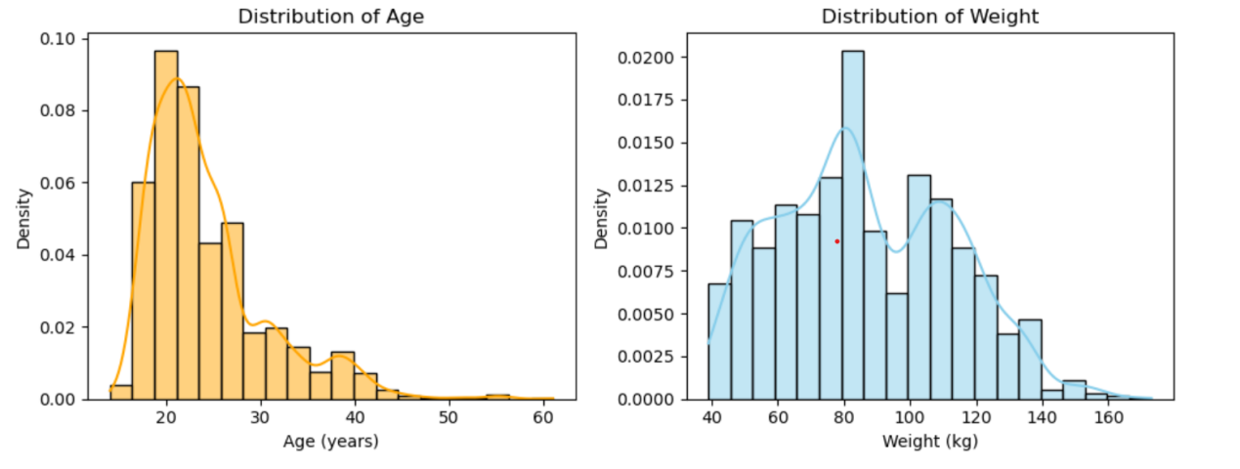
The Age distribution is positively skewed (right-skewed), with a skewness value of 1.53. Since the value is greater than 0.5, it indicates a noticeable long positive skew. Most participants are relatively young, while a smaller number of older participants create a longer tail on the right side of the distribution. Furthermore, kurtosis value of is 2.81, representing heavier tails than a normal distribution, meaning that extreme values may occur more frequently and does not close to the normal distribution.(Leptokurtic https://www.youtube.com/watch?v=dJKcTzDcwSU)
The weight distribution is sligtly positive skewed, with 0.25 value. Most participants are concentated in center, while a small number of people have higher weights, creating a little longer tail in the right side. And kurtosis value is -0.7, indicating it has lighter tails than a normal distribution. (platykurtic)
6.2 Normal distribution using QQ plot
A QQ plot is a scatterplot created by plotting two sets of quantiles against one another.
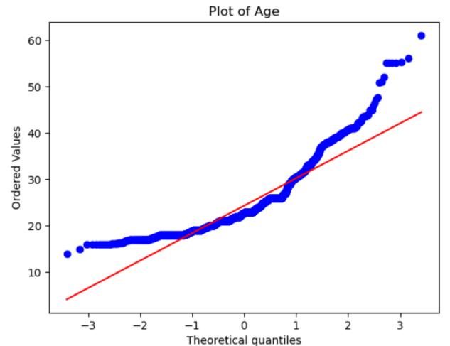
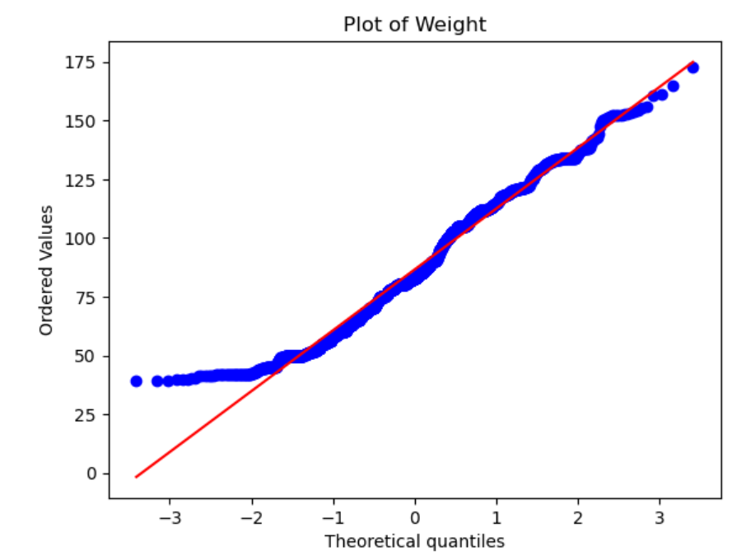
The QQ plots show that both Weight and Age deviate from the reference line, indicating that neither variable follows a perfectly normal distribution. The Weight plot shows some deviation at the lower end, while the Age plot shows a stronger deviation in the upper tail. This is consistent with the skewness results: Weight is slightly positively skewed (0.25), whereas Age is more strongly positively skewed (1.53).
- 7.1 Sampling Distributions of Weight and Age for Different Sample Sizes
Sampling was applied to the Age and Weight variables to investigate how different sample sizes affect the distribution of sample means. The sampling distribution of Age and Weight were analysed using different sample size(5, 15, 20, 25, 30, 35, and 50). For each sample size, 1000 samples were generated, and their means are calculated. The histograms show how the sample means are distributed. As sample size increases, the sample means generally become more concentrated around the population mean.
The sampling distributions show that the Weight means appear closer to a normal distribution when the sample size is 35, while the Age means appear more normally distributed at a sample size of 50.
7.2 The standard error (SE) was calculated for different sample sizes (n = 5, 10, 20, 30, 50 and 100). The results show that the standard error decreases as the sample size increases. For example, when the sample size increases from 5 to 100, the standard error decreases from 2.84 to 0.63.
- Correlation Matrix for Obesity dataset
The coefficient of correlation measures the strength and direction of a linear relationship between two variables.
Correlation analysis was used to examine the relationship between family_history_with_overweight and SMOKE and other numerical variables in the obesity dataset. Since these two variables are categorical, they were converted into numerical values before calculating the correlations. This method helps identify whether having a family history of overweight or smoking is associated with body weight.
- Correlation between Weight and Family_History: 0.496
It indicates a moderate positive relationship, person who has family over weight history tend to have over weight.
- Correlation between Weight and SMOKE: 0.025
It represents a weak positive relationship between smoking status and weight.
In heatmap correlation matrix, the highest positive correlation bewteen weight and height, around 0.46, following by FCVC and weight compared with other factors. Whereas, a slight negative correlation was observed between weight and TUE and FAF, respectively -0.05, -0.07

